27th November 2021
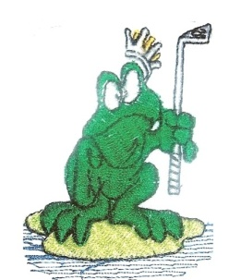
The results from the golf game played on the 27-11-2021 at Tamworth Golf Club
MAITLAND CITY BOWLS, SPORTS AND RECREATION CLUB

SOCIAL GOLF CLUB
The game played was a 4 Man Ambrose Event on our Trip Away. The weather was cloudy and fine, and the course was a bit wet. All had a great day out. We had 28 players played on the day. Buggies for all no carts too wet, we had to walk 9 holes.
Winners: Danny Mullen, Scott Gorton, Stephen Harris, Gary Cuthbert – 21.375 pts.
Second: Stuart Mullen, Matt Shannon, Mick Kelly – 21.50 pts.
Third: Matthew Wiggins, Josh Wilkinson, Steve Donnelly, Andrew Adamson – 21.75 pts.
Third Shot to the Green: Matt Shannon.
A Drive and Chip to the Green: NIL.
Nearest to the Pins: Josh Wilkinson, Craig Ramaker, Mathew Akers.
Our next game is at The Longyard Golf Club on the 28th November 2021. We will be playing a 4 Man Ambrose Event. This is the second golf game on our trip away.
CARTS FOR ALL
Good Golfing
Henry Meskauskas

