28th November 2021
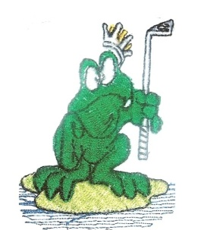
The results from the golf game played on the 28-11-2021 at Longyard Golf Club
MAITLAND CITY BOWLS, SPORTS AND RECREATION CLUB

SOCIAL GOLF CLUB
The game played was a 4 Man Ambrose Event on our Trip Away. The weather was cloudy and fine, and the course was great. All had a great day out. We had 36 players played on the day. Carts for All.
Winners: Josh Wilkinson, Barry Lamont, Mirko Lutovac, Mathew Akers – 53.25 pts.
Second: Matt Shannon, David Ellenor, Steven Donnelly, Spud Murphy – 54.88 pts.
Third: Henry Meskauskas, Alan Brew, Col Ede, James Mullen - 58.375 pts.
Third Shot to the Green: Matt Shannon.
A Drive and Chip to the Green: Josh Maslo.
Nearest to the Pins: Mark Morgan, Mark Meskauskas, Chris Wilkinson, Col Ede.
Our next game is at Hawks Nest Golf Club on the 9th January 2022. We will be a Single Stableford Event. This is the first game of golf for 2022. The bus will leave at 6.00am and tee is at 7.30am. Lunch at Hawks Nest.
CARTS FOR ALL
Good Golfing
Henry Meskauskas

