9th January, 2022

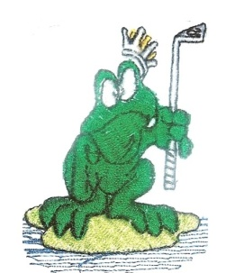
The results from the golf game played on the 9-1-2022 at Hawks Nest Golf Club
MAITLAND CITY BOWLS, SPORTS AND RECREATION CLUB

SOCIAL GOLF CLUB
The game played was a Single Stableford Event. The weather was rain, rain and then the sun came out and the course was in great condition. All had a great day out. We had 23 players played on the day.
Winner: Steve Donnelly – 44 pts. (On Count Back)
Second: Col Ede – 44 pts.
Third: Ross Cleary – 41 pts.
Third Shot to the Green: NIL.
A Drive and Chip to the Green: Tim Allen.
Nearest to the Pins: Ross Cleary, John Filipek, Ross Cleary.
Money Hole: No Winner hole 5.
Our next game is at The Springs Golf Club on the 20th February 2022. We will be playing a 4 Man Ambrose Event. The bus will leave at 6.00am and the tee off is at 7.30 am. Lunch will be at The Springs. The price is $70.00 for the game.
CARTS FOR ALL
Good Golfing
Henry Meskauskas

