29th MAY 2022

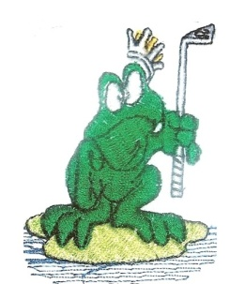
The results from the golf game played on the 29-5-2022 at Hunter Valley Golf Club
MAITLAND CITY BOWLS, SPORTS, AND RECREATION CLUB

SOCIAL GOLF CLUB
The game played was a Single Stableford Event. The weather was beautiful, and the course was in great condition after all the rain. All had a great day out. We had 19 players play on the day.
Winner: Rob McGrath – 38 pts.
Second: Josh Maslo – 37 pts.
Third: Stuart Mullen – 34 pts.
Third Shot to the Green: Josh Maslo.
A Drive and Chip to the Green: Samuel Breeze.
Nearest to the Pins: Allan Hutchinson, Phil Wright.
Money Hole: Hole 8 - NIL.
Our next game is at East Maitland Golf Club on the 12th June 2022. We will be playing a Single Stableford Event. The bus will leave at 6.30am and the tee off is at 7.30 am. Lunch will be at CMC. The price is $60.00 for the game.
CARTS FOR ALL
Good Golfing
Henry Meskauskas

